11.a) Compare and contrast single bus and Multiple bus organization of CPU?
Ans 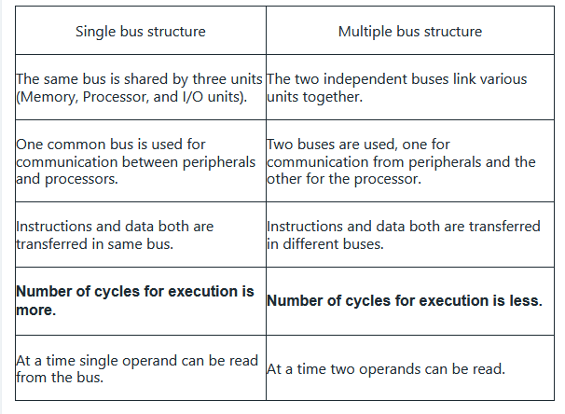
b)Write the three address,two address and one address representation of the operation below with relevant assumptions ,evaluate following?
i.(A+B)*(C+D)
ii C<-[A]+[B]
Ans.(A+B)*(C+D)
- Three Address
1,ADD A,B,R1;R1,<-M[A]+M[B]
2.ADD C,D,R2 ; R2<-M[C]+M[D]
3.MUL R1,R2,X; M[X]<-R1*R2
- Two Address
1.MOVA,R1 ; R1<-M[A]
2.ADD B ,R1 ;R1<-R1+M[B]
3.MOV C,R2 ; R2<-M[C]
4.ADD D,R2 ;R2<-R2+M[D]
5.MUL R2,R1 ; R1<-R1*R2
6. MOV R1,X ;M[X]<-R1
- One Address[AC-ACCUMULATOR]
1.LOAD A ; AC<-M[A]
2 .ADD B ;AC<-AC +M[B]
3.STORE T ; M[T]<-AC
4. LOAD C ; AC<-M[C]
5. ADD D ;AC<-AC+M[D]
6. MUT T ; AC<-AC*M[T]
7. STORE X ; M[X]<-AC

C<-[A]+[B]
- Three Adress
- ADD A,B,C ; C<-M[A]+M[B]
- Two Adress

- MOV A,R1 ;R1<-M[A]
- ADD B,R1 ;R1<-R1+M[B]
- MOV R1,C ; M[C]<-R1
One Address[AC-ACCUMULATOR]
- LOAD A ; AC<-M[A]
- ADD B ; AC<-AC+M[B]
- STORE C; M[C]<-AC
12 a) with the help of a neat figure ,Describe the data path inside the processor?
Ans) Programs reside in the memory through input devices.
• PC is set to point to the first instruction.
• The contents of PC are transferred to MAR. A read signal is sent to the memory.
• The first instruction is read out and loaded into MDR.
• The contents of MDR are transferred to IR.
• Decode and execute the instruction. Get operands for ALU (Address to MAR – Read
– MDR to ALU).
• Perform operation in ALU and Store the result back to general-purpose register.
• Transfer the result to memory (address to MAR, result to MDR – Write).
• During the execution, PC is incremented to the next instruction.
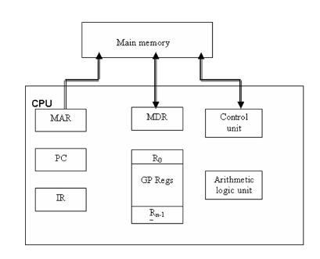
b) Draw the diagram of single bus organization ,write control sequence for the instruction ADD[R3],R1 for the above mentioned single bus organization?
Ans
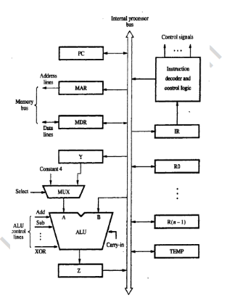
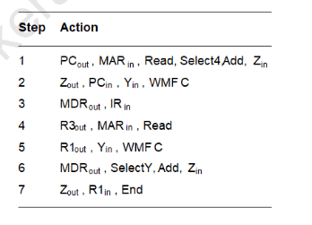
13 a) Describe Processor organization with diagram using i)Scratchpad memory ,ii) Two port memory ,iii) Accumulator register
Ans) The micro-operations within the processor during a given clock cycle can
be determined by the selection variables. The selection variables control the buses, the ALU, the shifter, and the destination register.
• A block diagram for the processing unit is shown in the below figure.
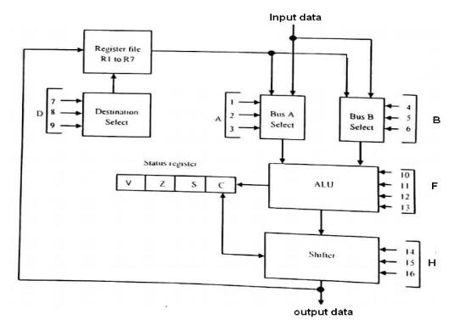t consists of seven registers (R1 to R7) and a status register. The output of the seven registers goes through two multiplexers to select the inputs to the ALU. • If the input is giving from any external source it can also accepting by the same multiplexers. The output from the ALU goes through a shifter and then to a set of external output terminals. • It is also possible to transfer the content from shifter to any one of the registers.
Accumulator register : Accumulator register is a multipurpose register capable of performing many micro-operations. The organization of a processor unit with an accumulator register is shown below.
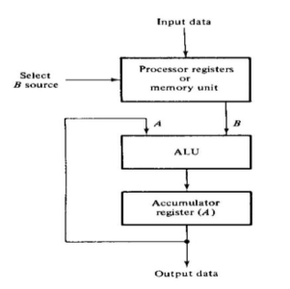
The ALU associated with the register maybe constructed as a combinational circuit. In this configuration, the accumulator register with parallel load is connected to the ALU.
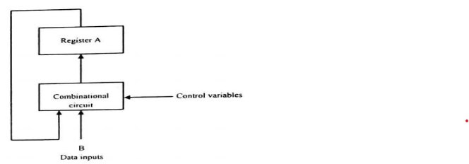
Scratchpad memory: Scratchpad memories can increase the performance of a processor by having faster access times. They can also shrink the die size of a chip from their reduced complexity leading to higher manufacturing yield or more on-chip memory or features.
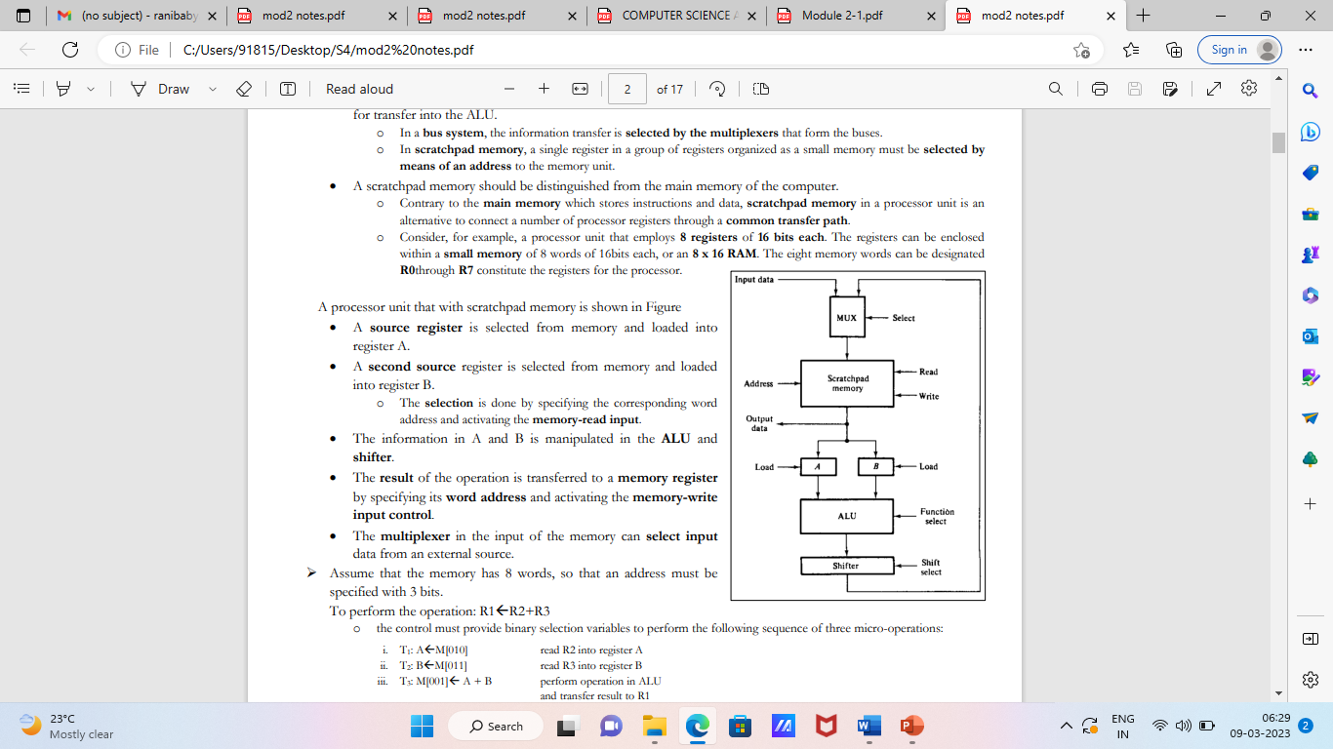
- Two port memory: Two port memory have two address lines to select two words of memory simultaneously. The two source registers can read at the same time.
- 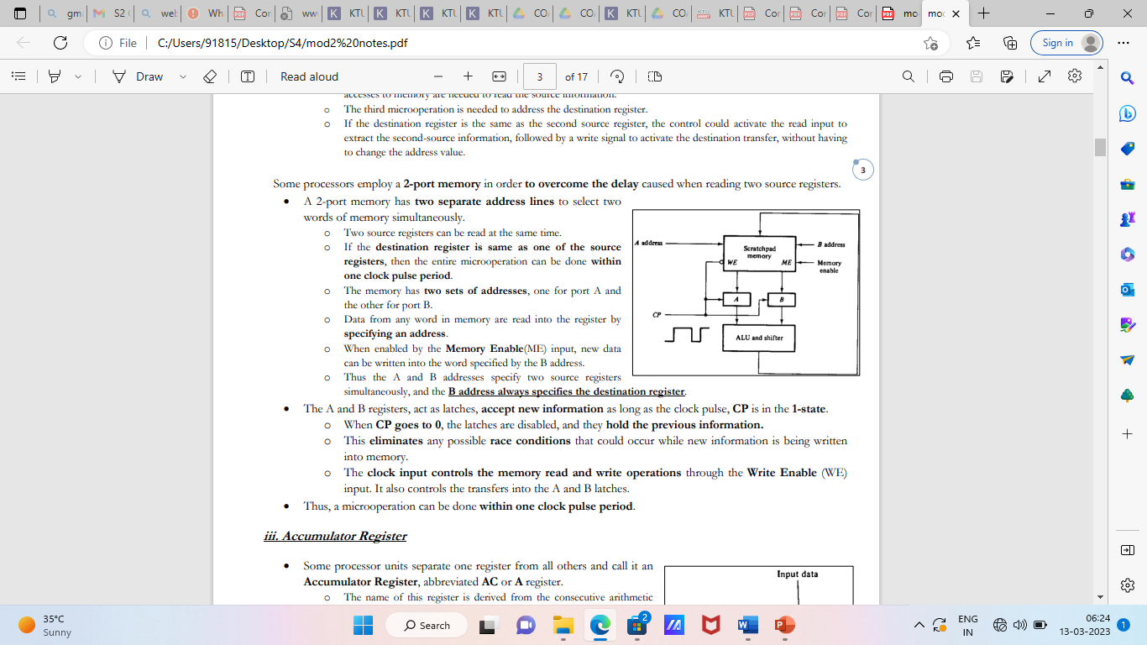

b) Draw and explain about true/complement circuit?
Ans . The basic component of the arithmetic section of an ALU is a parallel adder.
o A parallel adder is constructed with a number of full-adder circuits connected in cascade
• By controlling the data inputs to the parallel adder, it is possible to obtain different types of arithmetic
operations.
o The number of bits in the parallel adder may be of any value.
o The input carry Cin goes to the full-adder circuit in the least significant bit position.
o The output carry Cout comes from the full-adder circuit in the most significant bit position.
The circuit that controls input B to provide the functions is called a true/complement, one/zero element.
• This circuit is illustrated in the following figure.
The 2 selection lines s1 and s0 control the input of each B terminal.
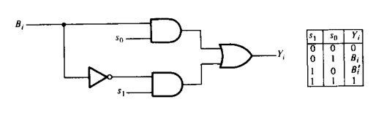
14 a) Give the structure of status register ,which is connected to 8 bit ALU.
Ans) The relative magnitude of two numbers may be determined by subtracting one number from the other and then checking certain bit conditions in the resultant difference. This status bit conditions are stored in a status register. The checking conditions may vary for signed and unsigned numbers. Status register is a 4-bit register. The four bits are C (carry), Z (zero), S (sign) and V (overflow). These bits are set or cleared as a result of an operation performed in the ALU.
1. Bit C is set if the output carry of an ALU is 1. It is cleared if the
output carry is 0.
2. Bit S is set to 1 if the highest order bit of the result in the output of
the ALU is 1. If the highest order bit is 0, this bit is cleared.
3. Bit Z is set to 1 if the output of the ALU contains all 0’s. That is if
the result is zero Z bit is 1, and if the result is nonzero Z bit is 0.
4. Bit V is set if the exclusive OR of carries C8 and C9 is 1, and cleared
otherwise. This is the condition for overflow when the numbers are
in Signed 2’s complement representation.
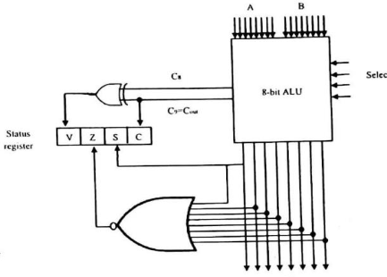

15 a) Draw the flowchart and explain restoring division method with an example?
Ans) A circuit that implements division by this longhand method operates as follows: It positions the divisor appropriately with respect to the dividend and performs a subtraction. If the remainder is zero or positive, a quotient bit of 1 is determined, the remainder is extended by another bit of the dividend, the divisor is repositioned, and another subtraction is performed. If the remainder is negative, a quotient bit of 0 is determined, the dividend is restored by adding back the divisor, and the divisor is repositioned for another subtraction. This is called the restoring division algorithm.
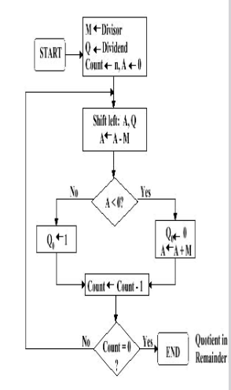
Figure shows a logic circuit arrangement that implements the restoring division algorithm just discussed. An n-bit positive divisor is loaded into register M and an n-bit positive dividend is loaded into register Q at the start of the operation. Register A is set to 0. After the division is complete, the n-bit quotient is in register Q and the remainder is in register A. The required subtractions are facilitated by using 2’s-complement arithmetic. The extra bit position at the left end of both A and M accommodates the sig he sign bit during subtractions. The following algorithm performs restoring division

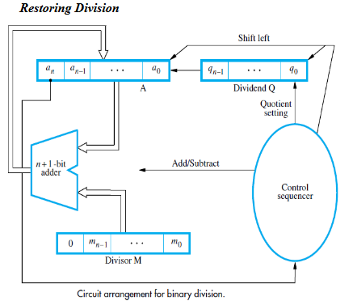
Do the following three steps n times:
1. Shift A and Q left one bit position.
2. Subtract M from A, ie; (A-M) and place the answer back in A.
3. If the sign of A is 1, set q0 to 0 and add M back to A (that is, restore A); otherwise, set
q0 to 1.
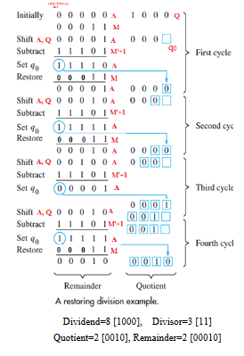
b) Describe in detail about data hazards and resolution techniques?
Ans) DATA HAZARDS
● We must ensure that the results obtained when instructions are executed in a pipelined
processor are identical to those obtained when the same instructions are executed
sequentially.
Hazard occurs
A ← 3 + A
B ← 4 × A
No hazard
A ← 5 × C
B ← 20 + C
When two operations depend on each other, they must be executed sequentially in the
correct order.
Another example:
Mul R2, R3, R4
Add R5, R4, R6
Operand Forwarding
● Instead of from the register file, the second instruction can get data directly from the
output of ALU after the previous instruction is completed.
● A special arrangement needs to be made to “forward” the output of ALU to the input of ALU.
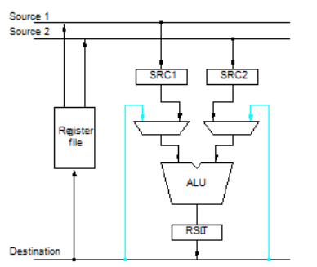
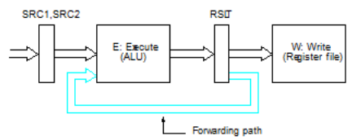
Handling Data Hazards in Software
● Let the compiler detect and handle the hazard:
I1: Mul R2, R3, R4
NOP
NOP
I2: Add R5, R4, R6

17a) With the help of a diagram explain the functioning of a microprogram sequencer in a microprogrammed controlled processor?
Ans) Micro program sequencer is a control unit which does the tasks of Micro-program
sequencing. There are two important factors must be considered while designing the micro
program sequencer.
o The size of the microinstruction
o The address generation time
Micro-program sequencer is attached to the control memory. It inspects certain bits in the
microinstruction to determine the next address for control memory. A typical sequencer has the following address sequencing capabilities.
1. Increments the present address of control memory
2. Branches to an address which will be specified in the bits of microinstruction
3. Branches to a given address if a specified status bit is equal to 1.
4. Transfers control to a new address as specified by an external source
5. Has a facility for subroutines calls and returns.
The address generation part is sometimes called a microprogram sequencer, since it
sequences the micro instructions in control memory. Subroutines are programs used by other routines to accomplish a particular task. Subroutine
can be called from any point within the main body of the microprogram. Frequently, many microprograms contain identical sections of code. Microinstructions can be saved by employing subroutines which use common section of microcode
The block diagram of Micro-program Sequencer is shown in the figure. It consists of a
multiplexer that selects an address from four sources and routes it into a Control Address
Register (CAR).
1. Transfers control to a new address specified by an external source (EXA).
2. Transfers control to a new address for subroutines call (SR) and returns.
3. Increments the present address of control memory (Incrementer)
4. Branches to an address which will be specified in the bits of microinstruction
(BRA).
• Multiplexer: Selects an address from four source s and routes it into CAR.
• The output from CAR provides the address for control memory to read a
microinstruction.
• The contents of CAR are incremented and applied to the multiplexer and to the stack
register file (SR)
• The register selected in the stack is determined by stack pointer (SP).
• Inputs (I0-I2) specify the operation for the sequencer and input.
• T is the test point for a status bit.
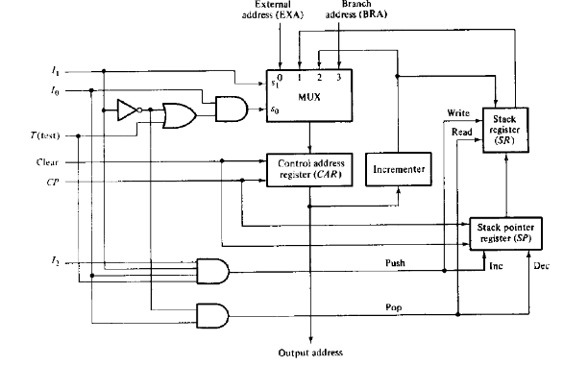
b) compare instruction formats of horizontal and vertical microinstructions?
Ans) . Horizontal Micro-instructions
Simplest way to structure microinstructions is to assign one bit position to each control
signal required in the CPU
Example: Control Sequence for instruction Add (R3), R1:
1. PCout, MARin, Read, Select4, Add, Zin
2. Zout, PCin, Yin, Wait for the MFC
3. MDRout, IRin
4. R3out, MARin, Read
5. R1out, Yin, Wait for MFC
6. MDRout, Select Y, Add, Zin
7. Zout, R1in, End

2. Vertical Micro-Instructions
We can reduce the length of the horizontal micro-instruction so easily by implementing
another method known as vertical micro-instructions. In this case, most signals are not needed
simultaneously and many others are mutually exclusive. Mutually exclusive signals are
grouped together.

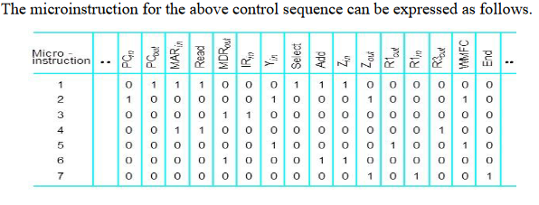

2. Vertical Micro-Instructions
We can reduce the length of the horizontal micro-instruction so easily by implementing
another method known as vertical micro-instructions. In this case, most signals are not needed
simultaneously and many others are mutually exclusive. Mutually exclusive signals are
grouped together.
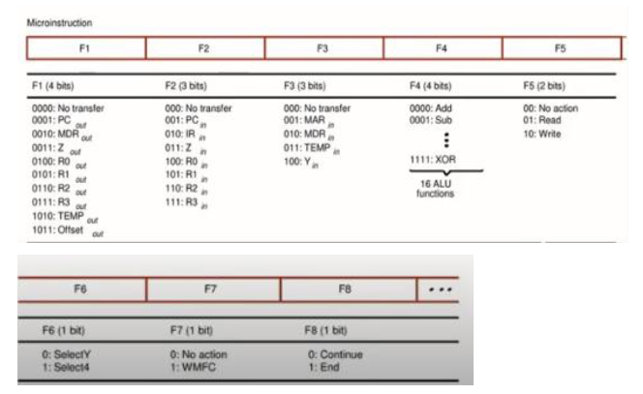

In a vertical microinstruction, a code is used for each action to be performed and the decoder translates this code into individual control signals. The vertical microinstruction resembles the conventional machine language format comprising one operation and a few operands. As opposed to horizontal microinstructions, the vertical microinstruction represents single micro-operations.
18) Explain the organization of micro-programmed computer with a block diagram ?
Ans) Micro-programmed computer
A computer CPU uses the micro-program sequencer. Micro-programmed computer
consists of
1. Memory unit: Stores instructions and data supplied by the user through an input device
2. Two processor unit:
Data processor: Manipulates data
Address processor: Manipulates the address information received from memory
3. A Micro-program sequencer
4. A control memory
5. Other digital functions
• An instruction extracted from memory unit during fetch cycle goes into instruction
register and is decoded.
• Corresponding to each opcode (Add, sub), there will be a micro routine in the control
memory.
• Code transformation constitutes a mapping function that is needed to convert the op
code bits of an instruction into a starting address for the control memory.
• It is implemented with ROM or PLA.
• Mapping concept provides flexibility for adding instructions or micro-operations for
control memory as need arises.
• The address generated in code transformation mapping function is applied to the
external address (EXA) input of the sequencer.
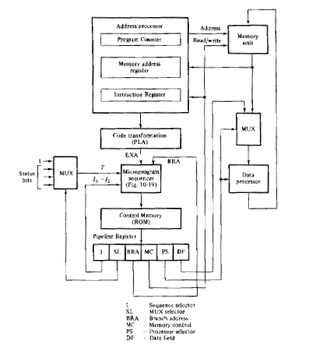
Micro-program control unit consists of
1. The sequencer: Generates next address
2. A control memory: Reads the next microinstruction while present microinstruction are
being executed in the other units of the CPU and for storing microinstructions
3. A multiplexer: Selects one of the many status bits and applies to the T(test) input of the
sequencer. One of the input of the multiplexer is always I to provide an unconditional
branch operation
A pipeline register: Speed up the control operation, allows next address to be generated and
the output of control memory to change while the current control word in pipeline register
initiates the micro-operations given by present microinstruction. It’s not always necessary
because the output of control memory can go directly to the control inputs of the various
units in the CPU.
Microinstruction format contains six fields:
First 3 fields (I,SL, BRA) provide information to the sequencer to determine the next address
for control memory.
I field (3 bits): Supplies input information for the sequencer
SL field: Selects a status bit for the multiplexer
BRA field: Address field of microinstruction and supplies a branch address (BRA) to the
sequencer.
The next 3 fields (MC, PS, DF) are for controlling micro-operations in the processor and the
memory units
Memory control (MC) field: Controls the address processor and the read and write
operations in the memory unit.
The processor select(PS) field: Controls the operations in the data processor unit.
The data field(DF): Used to introduce constants into the processor
Output from data field may be used to set up control registers and introduce data in processor
registers.
b) Explain with an example one flip-flop per state method of control organization?
Ans) One flip-flop per state methods
This method uses one flip-flop per state in the control sequential circuit. Only one flip-
flop is set at any particular time: all others are cleared. A single bit is made to propagate from
one flip-flop to the other under the control of decision logic. In such an array, each flip-flop
represents a state and is activated only when them control bit is transferred to it. In this method, maximum numbers of flip-flops were used. Example: A sequential circuit with 12 states requires a minimum of four flip-flops because 23< 12< 24. Control circuit uses 12 flip-flops, one for each state The advantage of this method is the simplicity with which it can be designed. This type of controller can be designed by inspection from the state diagram that describes the control sequence. This also offers other advantages like savings in design effort, an increase in operational simplicity, and a potential decrease in the combinational circuits required to implement the complete sequential circuit. The disadvantage is that this method would increase system cost since more flip-flops are used.
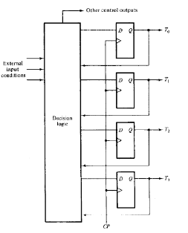
19 a) Explain in detail about the mechanisms for accessing I/O devices?
Ans) ACCESSING I/O DEVICES
A simple arrangement to connect I/O devices to a computer is to use a single
Bus structure. It consists of three sets of lines to carry
❖ Address
❖ Data
❖ Control Signals.
When the processor places a particular address on address lines, the devices that recognize this address responds to the command issued on the control lines. The processor request either a read or write operation and the requested data are transferred over the data lines.
When I/O devices & memory share the same address space, the arrangement is called memory mapped I/O.
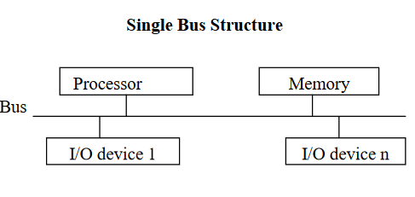
Move DATAIN, Ro - Reads the data from DATAIN then into processor register Ro.
Move Ro, DATAOUT - Send the contents of register Ro to location DATAOUT.
DATAIN - Input buffer associated with keyboard.
DATAOUT - Output data buffer of a display unit / printer.
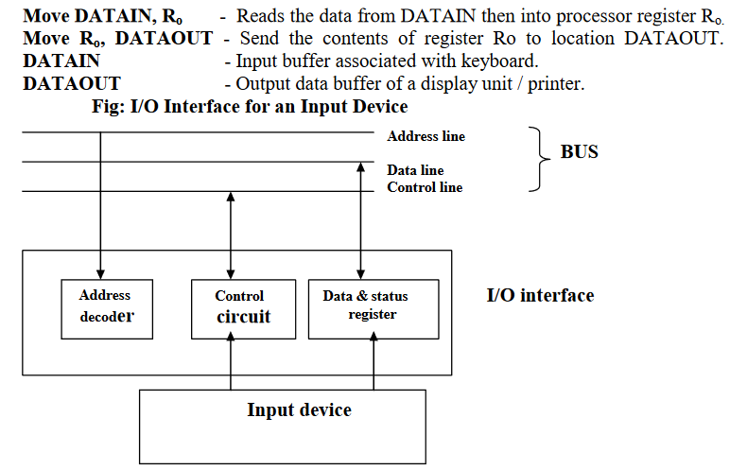
Address Decoder:
It enables the device to recognize its address when the address appears on address lines.
Data register - It holds the data being transferred to or from the processor.
Status register - It contains information relevant to the operation of the I/O devices.
The address decoder, data & status registers and the control circuitry required to
co-ordinate I/O transfers constitute the device‟s I/O interface circuit.
For an input device, SIN status flag is used SIN = 1, when a character is entered at the keyboard, SIN = 0, once the char is read by processor. For an output device, SOUT status flag is used?
b) Discuss about different read only memories ?
Ans) READ ONLY MEMORY
SRAM and SDRAM chips are volatile: Lose the contents when the power is turned off.Many applications need memory devices to retain contents after the power is turned off.
For example, computer is turned on; the operating system must be loaded from the diskinto the
memory. For this we need to store instructions which would load the OS from the disk that they will not be lost after the power is turned off. So we need to store the instructions into a non-volatile memory. Non-volatile memory is read in the same manner as volatile memory. The normal operation involves only reading of data, this type of memory is called Read-Only memory (ROM). The data are written into a ROM when it is manufactured and is permanent memory.
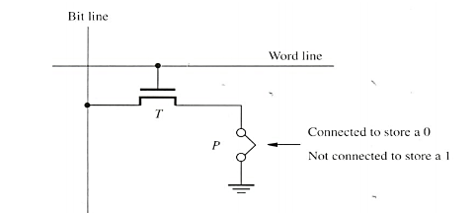
Types of ROM
Different types of non-volatile memory are
• PROM
• EPROM
• EEPROM
• Flash Memory
Programmable Read-Only Memory (PROM):
PROM allows the data to be loaded by the user. Programmability is achieved by inserting a
„fuse‟ at point P in a ROM cell. Before it is programmed, the memory contains all 0‟s. The user can
insert 1‟s at the required location by burning out the fuse at these locations using high-current pulse.
This process is irreversible.
The PROMs provides flexibility and faster data access. It is less expensive because they can be programmed directly by the user.
Erasable Reprogrammable Read-Only Memory (EPROM):
EPROM allows the stored data to be erased and new data to be loaded. In an EPROM cell, a
connection to ground is always made at „P‟ and a special transistor is used, which has the ability to function either as a normal transistor or as a disabled transistor that is always turned „off‟. During programming, an electrical charge is trapped in an insulated gate region. The charge is retained for more than 10 years because the charge has no leakage path. For erasing this charge, ultra- violet light is passed through a quartz crystal window (lid). This exposure to ultra-violet light dissipates the charge. During normal use, the quartz lid is sealed with a sticker.
EPROM can be erased by exposing it to ultra-violet light for duration of up to 40 minutes. Usually, an EPROM eraser achieves this function.
Merits: It provides flexibility during the development phase of digital system. It is capable of
retaining the stored information for a long time.
Demerits: The chip must be physically removed from the circuit for reprogramming and its
entire contents are erased by UV light.
Electrically Erasable Programmable Read-Only Memory (EEPROM):
EEPROM is programmed and erased electrically. It can be erased and reprogrammed about ten
thousand times. Both erasing and programming take about 4 to 10 ms (millisecond). In EEPROM, any location can be selectively erased and programmed. EEPROMs can be erased one byte at a time, rather than erasing the entire chip. Hence, the process of reprogramming is flexible but slow.
Merits:It can be both programmed and erased electrically. It allows the erasing of all cell
contents selectively. Demerits:It requires different voltage for erasing ,writing and reading the stored
data.
Flash memory:
Flash memory is a non-volatile memory chip used for storage and for transferring data between a
personal computer (PC) and digital devices. It has the ability to be electronically reprogrammed and
erased. It is often found in USB flash drives, MP3 players, digital cameras and solid-state drives.
Flash memory is a type of electronically erasable programmable read only memory (EEPROM),
but may also be a standalone memory storage device such as a USB drives. EEPROM is a type of data
memory device using an electronic device to erase or write digital data. Flash memory is a distinct type
of EEPROM, which is programmed and erased in large blocks.
Flash memory incorporates the use of floating-gate transistors to store data. Floating-gate
transistors, or floating gate MOSFET (FGMOS), is similar to MOSFET, which is a transistor used for amplifying or switching electronic signals. Floating-gate transistors are electrically isolated and use a
floating node in direct current (DC). Flash memory is similar to the standard MOFSET, except the transistor has two gates instead of one.
20 a)Explain internal organization of 1K *8 memory chip with suitable diagram?
Ans) Large dynamic memory systems can be implemented using DRAM chips in a similar way to static memory systems. Placing large memory systems directly on the motherboard will occupy a large amount of space. Also, this arrangement is inflexible since the memory system cannot be expanded easily.
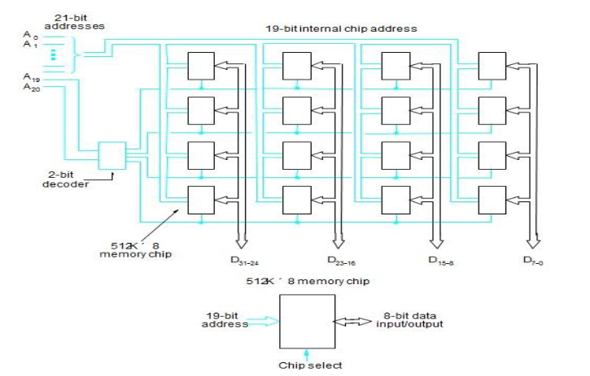
b) How does the various mapping scheme present in cache memory differ from each other?
Ans) The mapping functions are used to map a particular block of main memory to a particular block of cache. This mapping function is used to transfer the block from main memory to cache memory.
Mapping functions determine how memory blocks are placed in the cache.
Three mapping functions:
• Direct mapping.
• Associative mapping.
• Set-associative mapping.
Direct Mapping
A particular block of main memory can be brought to a particular block of cache memory. So, it is not flexible. The simplest way of associating main memory blocks with cache block is the direct mapping technique. In this technique, block k of main memory maps into block k modulo m of the cache, where m is the total number of blocks in cache. In this example, the value of m is 128. In direct mapping technique, one particular block of main memory can be transferred to a particular block of cache which is derived by modulo function. Example:Block j of the main memory maps to j modulo 128 of the cache. (ie) Block 0, 128, 256 of main memory is maps to block 0 of cache memory.1,129,257 maps to 1, & so on. More than one memory block is mapped onto the same position in the cache. This may lead to contention for cache blocks even if the cache is not full. Resolve the contention by allowing new block to replace the old
block, leading to a trivial replacement algorithm. Memory address is divided into three fields: Low order 4 bits determine one of the 16 words in a block. When a new block is brought into the cache, the next 7 bits determine which cache block this new block is placed in. High order 5 bits determine which of the possible32 blocks is currently presentin the cache. These are tag bits. This mapping methodology is simple to implement but not very flexible.
Associative mapping
In the associative mapping technique, a main memory block can potentially reside in any cache
block position. In this case, the main memory address is divided into two groups, a low-order bit identifies the location of a word within a block and a high-order bit identifies the block.
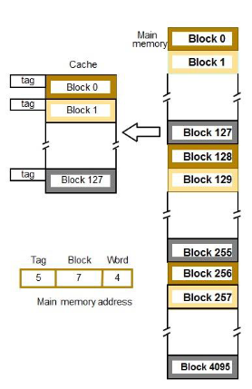
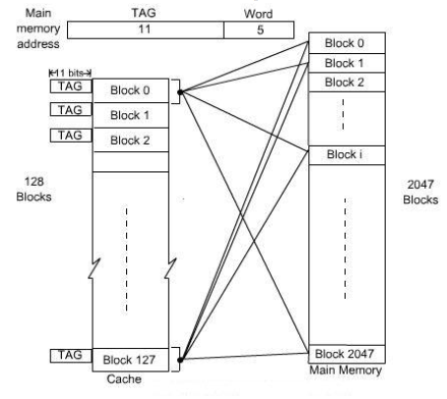
In the associative mapping, any block of main memory can go to any block of cache, so it has
got the complete flexibility and we have to use proper replacement policy to replace a block from cache if the currently accessed block of main memory is not present in cache. It might not be practical to use this complete flexibility of associative mapping technique due to searching overhead, because the TAG field of main memory address has to be compared with the TAG field of the entire cache block.
Set-Associative mapping
This mapping technique is intermediate to the previous two techniques. Blocks of the cache are grouped into sets, and the mapping allows a block of main memory to reside in any block of a specific set. Therefore, the flexibility of associative mapping is reduced from full freedom to a set of specific blocks. This also reduces the searching overhead, because the search is restricted to number of sets, instead of number of blocks. Also the contention problem of the direct mapping is eased by having a few choices for block replacement.
Consider the same cache memory and main memory organization of the previous example.
Organize the cache with 4 blocks in each set. The TAG field of associative mapping technique is divided into two groups, one is termed as SET bit and the second one is termed as TAG bit. Each set contains 4 blocks, total number of set is 32. The main memory address is grouped into three parts: low- order 5 bits are used to identifies a word within a block. Since there are total 32 sets present, next 5 bits are used to identify the set. High-order 6 bits are used as TAG bits.
